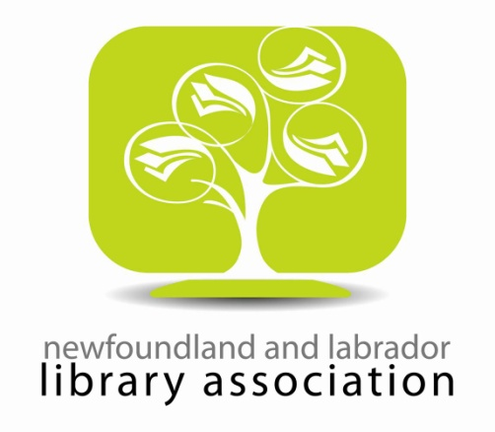
Annual Conference, May 13, 2013
The Fluvarium, St. John’s.
The Cut of your Jib: Embracing Culture in Our Libraries
“Progress is a Tide. If we stand still we will surely be drowned.
To stay on the crest, we have to keep moving”
Harold Mayfield
This year’s theme will showcase the unique cultural character in our libraries’ collections, public services, research, and daily activities. Consider the idea of progress in Newfoundland and Labrador libraries with our culture, traditions, and individuality in mind.
Possibilities include:

Reference Services
Collection Development
Special Collections and Archives
Music Collections (ex. folk music collections)
Ebooks and Eresources
Library as Space
Community Services and Programs
Copyright
Website Design
Outreach
Mobile Devices/ Technology
Digitization
Open Access
The committee is requesting submissions for one of TWO (2) types of presentations:
- 30 minute presentations with 15 minutes for questions
- Lightning Round Sessions: 5-8 minute long presentations for those with valuable research, program information and events, and knowledge to share, in a shorter timeframe.
We are also asking for photos of your collections, libraries, displays, and anything that embodies the idea of progress or culture in your library. Please include the following information: the library name and an explanation of how this year’s theme is captured.
Presentation proposals (maximum 1 page) and/ or photos can be forwarded to the Chair of the programming committee, Amanda Tiller (atiller@mun.ca). Photos can also be mailed to the NLLA at:
Newfoundland and Labrador Library Association
PO Box 23192
Churchill Square, St. John’s, NL
A1B 4J9
Deadline for submissions: Papers/ Presentations: April 12, 2013; Photos: May 1, 2013.

