The Parent-Child Mother Goose Program®

Teacher Training Workshop April 5 & 6, 2013
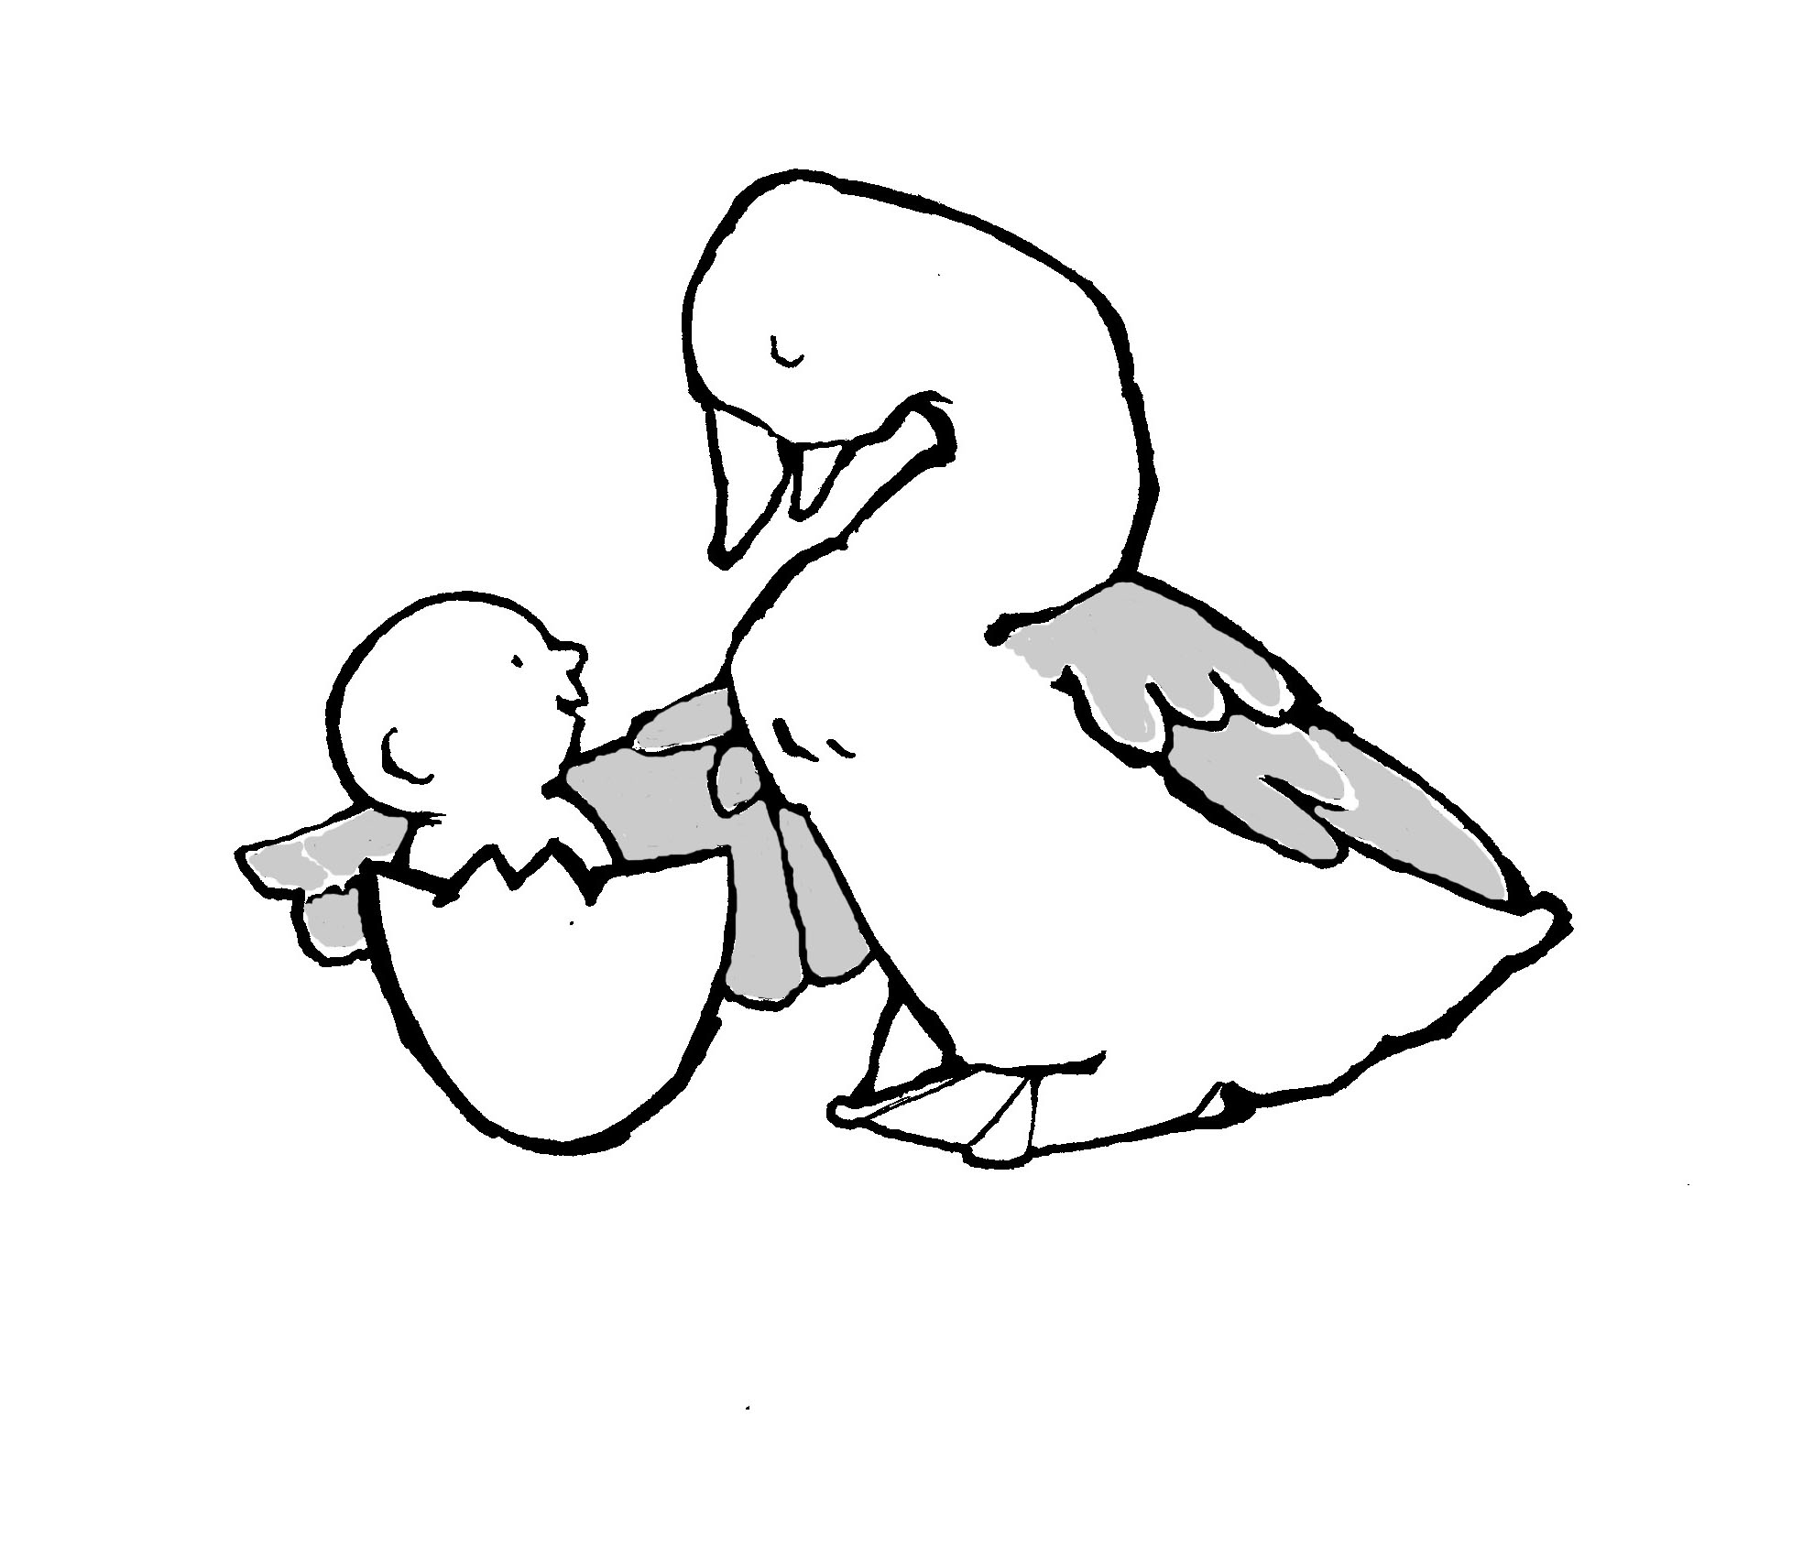
In a 2006 national survey the Parent-Child Mother Goose Program® received more 5-star ratings from service agencies than any other parent-child program in the country.

The Parent-Child Mother Goose Program is a group experience for parents and their babies and young children focusing on the pleasure and power of using oral and through the air rhymes, songs, and stories together.

Teacher Training Workshop covers:
- The Philosophy and Objectives of the Parent-Child Mother Goose Program.
- The Material of the Parent-Child Mother Goose Program, including:
Rhymes - many examples of interactive rhymes; how they fit into the program, how to use interactive rhymes and, how to teach them to parents.
Songs - learn lullabies and dancing songs; when to use them and how to teach them to parents.
Storytelling – why it’s an essential part of the program; how to learn and tell a story, and enjoy it!
- The Logistics of how to run a Parent-Child Mother Goose Program - from setting up a group, to putting out the mats, to saying goodbye.

Trainer:
This workshop will be led by Beth Hutchinson. She is a program teacher, trainer, and the Provincial Co-ordinator of the P-CMGP. She also had been an IDP Consultant in the Vancouver IDP since 1994. Beth fell in love with the P-CMGP while leading in the first program in BC. It had way more laughter, tons more smiles, a lot more fun and way more depth of joy and satisfaction than she had expected.

The Cost of the Workshop includes:
- P-CMGP Teacher Training Manual
- Rhymes and Songs booklet
- P-CMGP Forms booklet and other resources
- Free 6-month membership
- A P-CMGP Welcome Poster for new Programs
- Access to on-line follow-up support

Variety of additional resources will be available for sale at the workshop

After attending this workshop you will receive a certificate and are able to start running a Parent-Child Mother Goose Program.
*Please note that all Parent-Child Mother Goose Programs must be taught by two trained teachers.

When: April 5 & 6, 2013 / 8:45am to 4:00pm both days
Where: 3455 Kaslo St. (Vancouver Infant Development Program office)
Cost: $215 (before March 15, 2013); $240 (after March 15, 2013)
Facilitator: Beth Hutchinson

Lunch, snacks, and morning tea and coffee will be provided. Both days include an hour break for lunch.

Registration:
To register, please fill out the page which follows. Return by mailing, faxing, or e-mailing followed by a cheque payment. We expect this workshop to fill, so please register early. A confirmation letter will be sent to you following the receipt of your Registration Form and cheque. Directions for finding the Vancouver IDP office will be enclosed.

(The deadline for Registration is March 29, 2013.)

Cancellation Policy:
If cancelling your registration, your fee will be returned minus a $50.00 administration fee.

Parent-Child Mother Goose Program®
Registration Form: Teacher Training Workshop, April 5 & 6, 2013
*Please provide all the information requested to ensure you receive your certificate.

Your Name:__________________________________________
Your Address:___________________________________________________________
City:___________________________________Prov:_________PostalCode:_________

Home Phone:(_______)________________Email:_______________________________

Your Agency’s Name:_____________________________________________________
Name of Main Contact Person:_____________________Position:__________________
Agency Address:_________________________________________________________
City:____________________________________Prov:______Postal Code:_________

Work Phone:(_______)_________________Email:_____________________________

- Is your agency currently running a P-CMGP? Yes No
- Are you currently teaching in a P-CMGP? Yes No

Special Diet Restriction:

PAYMENT

Total cost of workshop is $215 (before March 15th); $240 (after March 15th)

- Cheque enclosed in the amount of: _$______________________

Please make cheque out and mail to:

Attn: Noreen Shuen

Vancouver IDP

3455 Kaslo Street

Vancouver, BC, V5M 3H4

Phone: 604-435-8166

Fax: 604-709-4553

E-mail: nshuen@develop.bc.ca

